WHAT IS GRIEF?
Grief is a strong emotion that people experience when they lose someone or something that was close to them or important to them.
It is a natural reaction. It can affect everyone differently.
There is no time limit to grief.
There is no right or wrong way to grief a loss.
Grief
Grief can occur from any type of loss. This can include death of a loved one, loss of friendship, a break-up, a pet dying, moving away from home, loss of independence, loss of a job, change is staff.

Stages of Grief
The common stages of grief that people experience include: Denial, anger, bargaining, depression, and acceptance. These stages can come and go in any order and can last for different lengths of time.

Common Feelings
Some common feelings experienced during times of grief include: sadness, anger, anxiety, shock, loneliness, shock, loneliness, abandonment, frustration, guilt, and numbness. Some may also experience self-blame and/or relief, depending on circumstances around the loss.
It is important to note that not everyone will experience the same feelings or with the same intensity. What one feels is that person truth.

Physical Sensations
There are often physical sensations associated with grief, including:
Loss of appetite or an empty feeling in the stomach
Tightness in the chest or throat
Aches and pains
Headaches
Fatigue and insomnia
Irritability, being overly sensitive to noise
Tearfulness
Shortness of breath
Dry mouth
Lack on physical strength / feeling weak and lacking energy.
It is important to take care of your physical health while coping with grief. As hard as it may be, thry to sleep well, exercise and eat healthy foods.

Thoughts Often Experienced While Grieving
Disbelief- typically when one first learns of a loss. May also have a sense of depersonalization (nothing seems real)
Confusion, including difficulties concentrating and inability to organize one’s thoughts.
Forgetfulness
Preoccupation – constant thoughts about the loss.
For those experience a loss through death there can some time be a sensing of the presence of the deceased, visual or auditory.

Behaviors Often Experienced While Grieving
Change in appetite and sleep patterns
Absent-minded behavior or restless over-activity
Social withdrawal
Avoidance of thing that are reminders of the loss
Dreaming of the deceased or the loss
Crying
Visiting places of carrying mementos of the deceased

Healthy Ways to Cope with Grief
It is important to find healthy ways to cope as you move through the journey of grief to the point of acceptance.
Acknowledge your pain and accept your feelings. You can’t avoid your feelings for ever. Trying to avoid feelings of sadness and loss actually prolongs the grieving process.
Accept that grief can trigger many different and unexpected emotions.
Express your feelings in a tangible or creative way.
Maintain your hobbies and interests.
Understand that your grieving process will be unique to you.
Seek out face-to-face support from people who care about you.
Plan ahead for grief triggers- holidays, anniversaries, milestone.
Support yourself emotionally by taking care of yourself physically.
Draw comfort from your faith.
Join a support group.
Remember your feelings are yours. Don’t let anyone tell you how to feel.

PWSA I USA has a variety of resources to help with healthy ways to cope with grief. You can contact a Family Support Counselor by calling 941-312-0400.
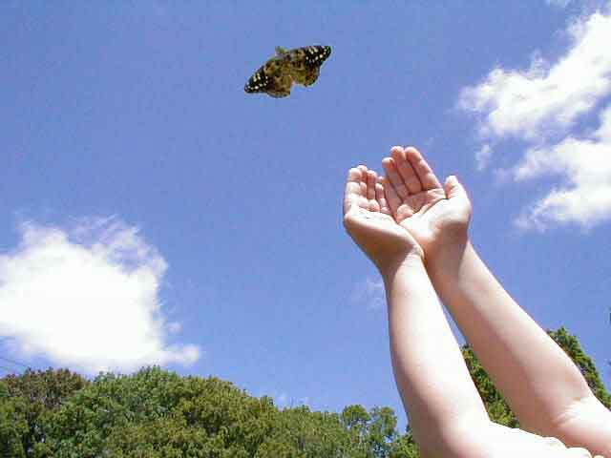
This Photo by Unknown Author is licensed under CC BY-NC-ND
KMT 3/2021

