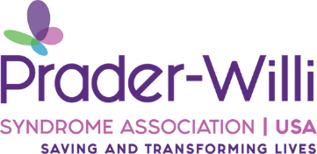

To Whom It May Concern:

You are about to give a family a diagnosis that will forever change their lives. This diagnosis comes with many challenges and the family will have so many questions. They don’t need all of the information right away, what they need is to hear “congratulations, your baby is beautiful.”

Before you go in to deliver this life altering diagnosis, please remember that the parents waiting breathlessly for your words have waited 9 months to hold their baby. Remember that there is a beautiful baby that is far more than a diagnosis that needs only to be accepted and loved exactly the way they are.

The parents are already terrified, they have been waiting anxiously for an answer as to why their baby is in the NICU. The vision they had for their child is about to disappear and be replaced with a lot of unknowns. Please encourage them to reach out to PWSA | USA, we have up to date information and an endless amount of support to offer all of our families.

The future of any child is unknown, it is no different for children with PWS. Each of our children are unique and will have varying symptoms with this diagnosis. The only guarantee that you can give the parents is that their child is going to bring them an immeasurable amount of joy.

There will be plenty of time in the coming months for the family to learn all they can about Prader-Willi syndrome, right now they need to know everything will be ok.

