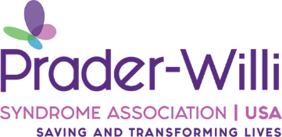

Hi, I know you were not expecting me to come into this world so quiet and struggling with almost everything. I know you are scared, please don’t be.

You may have just heard that I have Prader-Willi syndrome, you probably never heard of it and that’s ok. We will be brave and learn about it together. I am still the baby you talked to and sang to daily. I could hear your voice and I couldn’t wait to finally get to feel your loving arms around me. I am the same baby that you had hopes and dreams for, that hasn’t changed. I still need you to believe in me, to encourage me and to set the bar high, I will surprise you with my determination.

I will never know anything different than having PWS, just love me and accept me exactly the way I am and I will grow into a confident, happy child.

I know this diagnosis wasn’t part of our plan but I promise together we can do anything.
PWS is only a small part of who I am, I am so much more!

