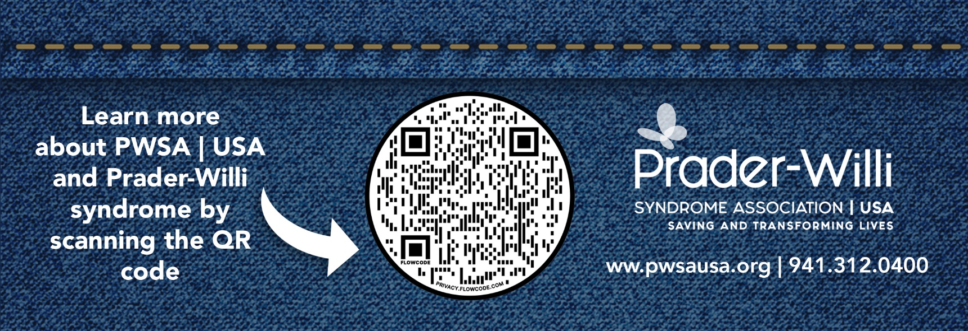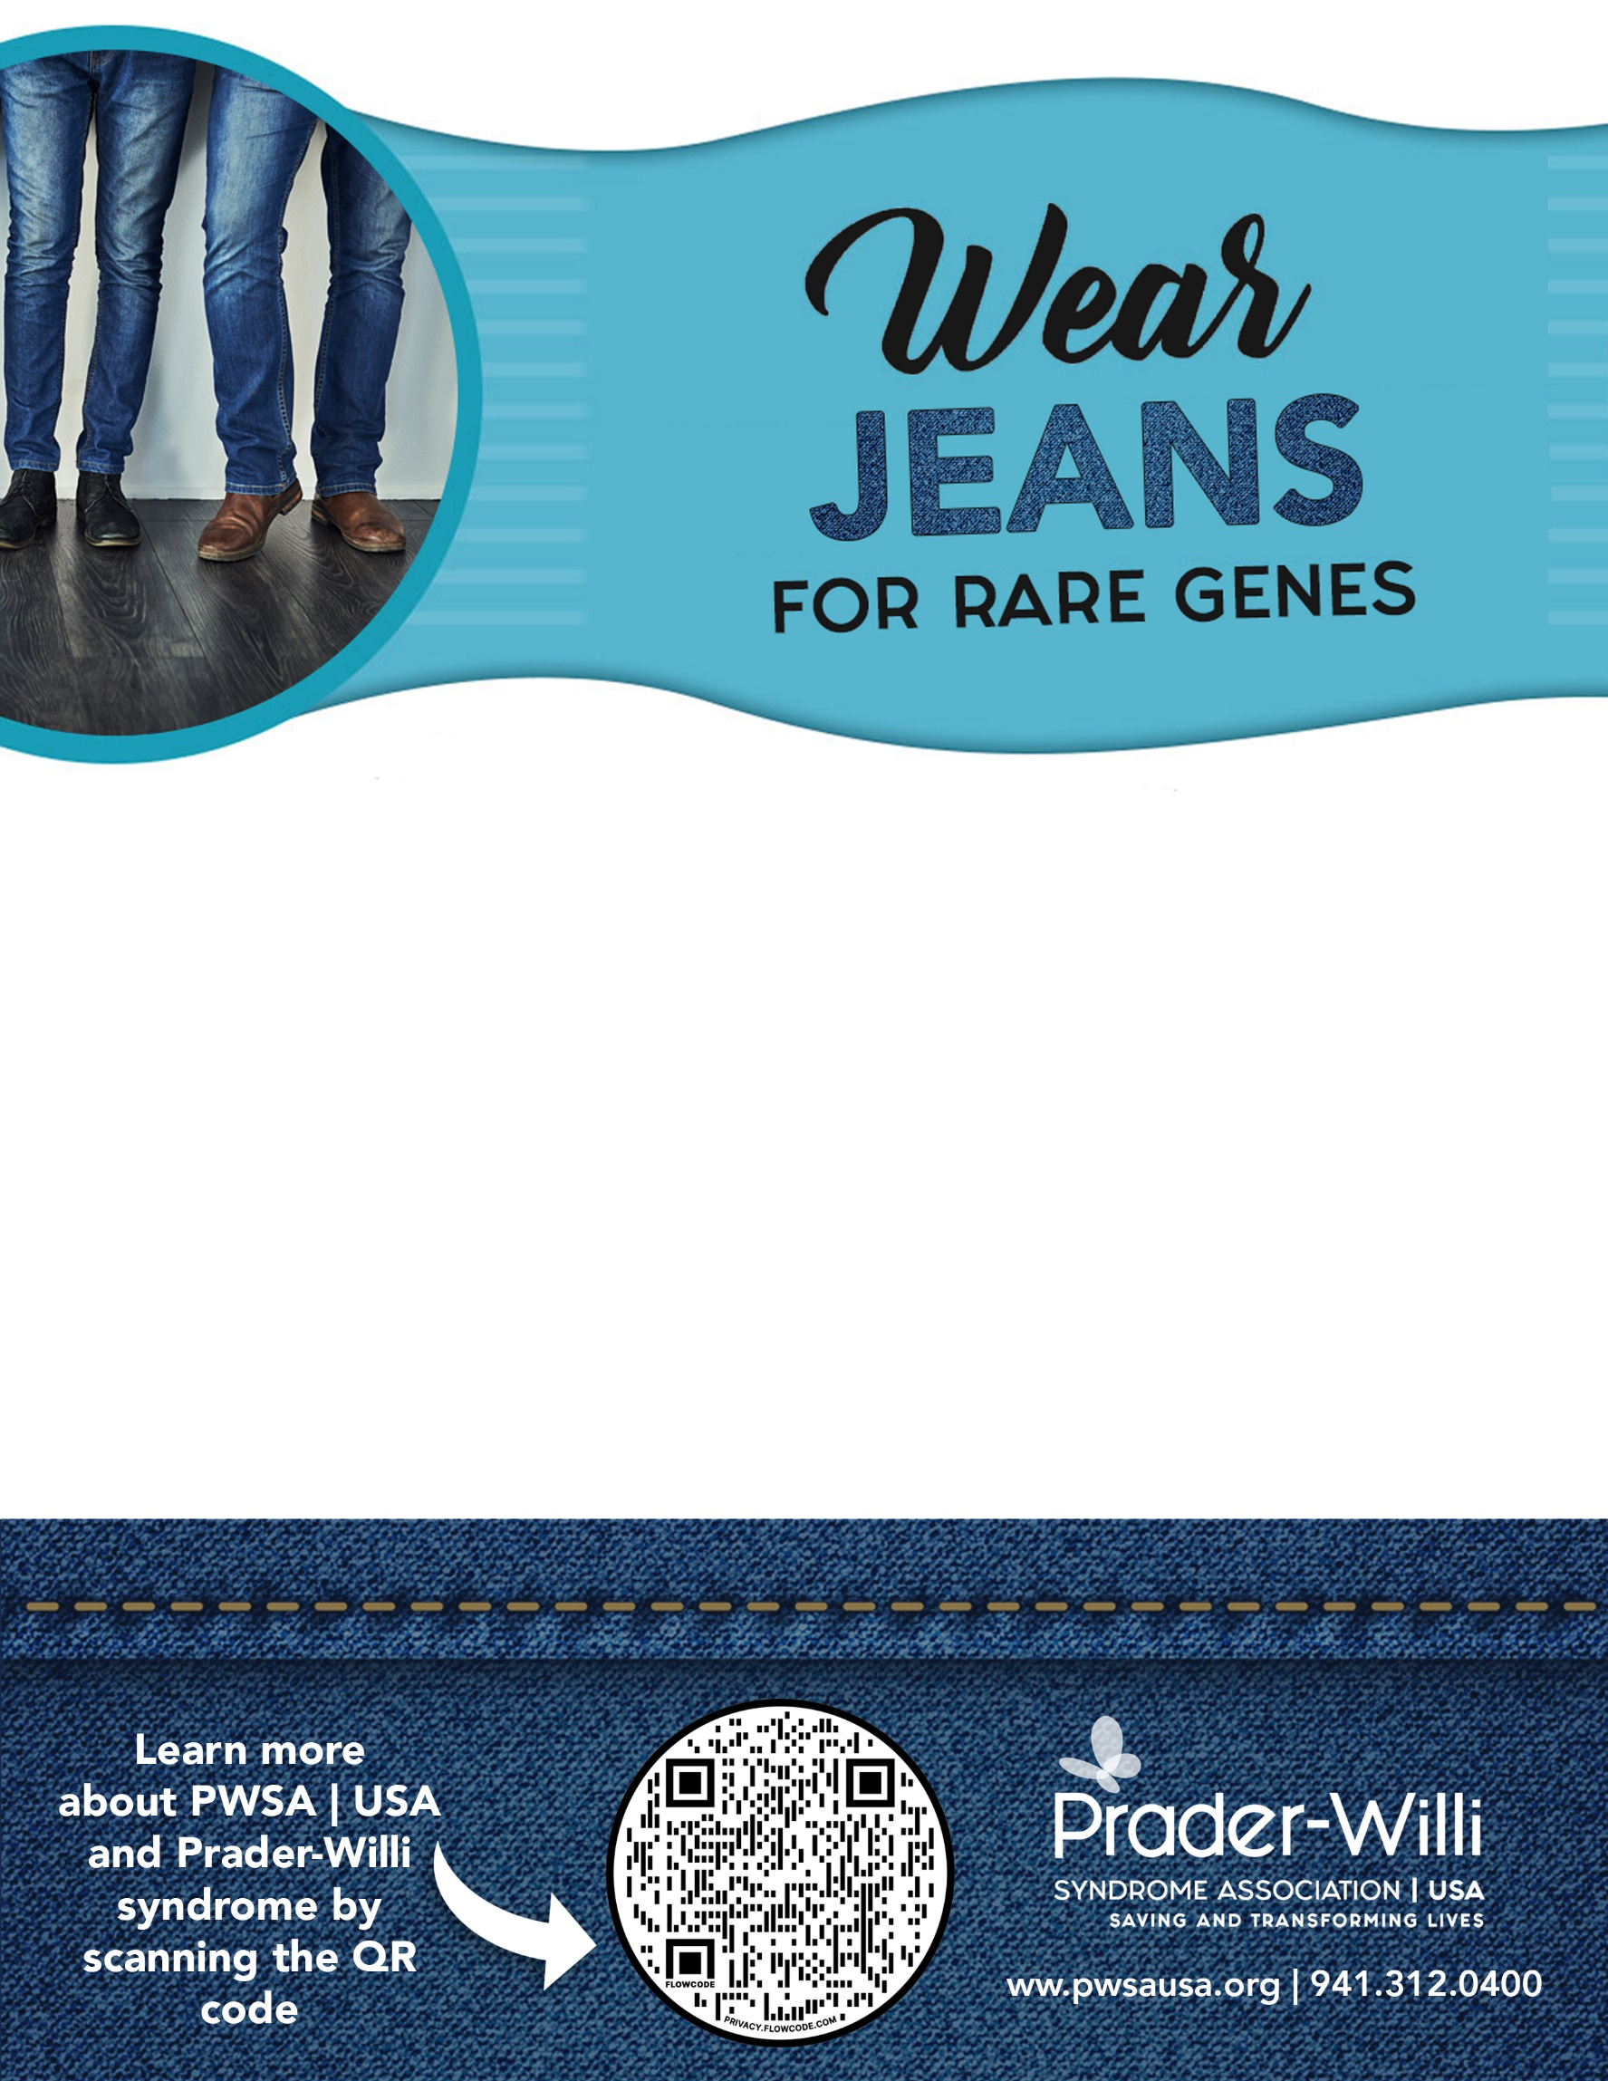

**Join us at <<insert name of school/workplace>>**

**On <<insert date(s)>>**

As we all Wear Jeans for Rare Genes in support of Prader-Willi Syndrome (PWS) - a rare diagnosis effecting one in 15,000 births

every year.

To participate, simply wear your jeans on this day and bring <<recommended amount>> [$1 for schools, $5-$25 for workplaces] to show your support! All donations we collect will be sent to Prader-Willi Syndrome Association | USA to advance research to treat individuals with PWS.

***Together we can make a difference!***