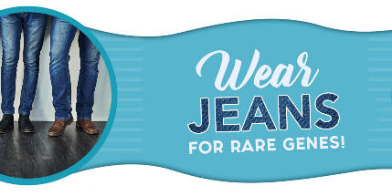

Formal Salutation <<Today’s Date>>
Name of Place
Address 1
Address 2
City, State, Zip

Salutation,

I am reaching out to ask for your <<school/workplace/church/program>> partnership to help raise awareness for Rare Disease that affect families in our community. You all know <<name of individual with PWS>>, but did you know that Prader-Willi Syndrome (PWS) is one of over 7,000 rare diseases that affect over 300 million people globally? More than 30 million Americans (1 in 10) live with one or more rare diseases and 95% of rare diseases have no FDA approved treatment or cure. It is also a fact that 50% of rare disease patients are children and sadly, 30% of children with a rare disease won’t live to see their 5th birthday.

This year, I’m working to raise awareness for rare disease and to celebrate our <<school/office/church/program>> as a welcoming, safe, and supportive place for those with rare disease and their caregivers. Participating is as easy as 1, 2, 3 and your involvement can have a great impact!

- Pick a Day and let us know! Pick any day on the calendar and make it a day to “Wear Jeans for Rare Jeans”- If you usually dress up, wear a uniform, or your “Sunday best” encourage people to wear jeans on this special day. Make it a fun and special occasion! Email us at events@pwsausa.org to let us know when you will be participating!
- Ask participants to donate ($1, $5, $10, or whatever is comfortable) for the opportunity to participate. Consider a friendly competition between <<classes, departments, branches>> perhaps? Each dollar collected will help PWS families living with rare disease get the specialized support they need.
- Celebrate and share your success! Take a photo and email it to events@pwsausa.org so that we can celebrate your efforts and use your success to inspire others!

As a member of the PWS community and the <<school/workplace/church/etc>>, I am happy to help coordinate this as a volunteer in whatever ways would be supportive. At the conclusion of your event, you can simply mail your donations in one check to the address below or make your donation through our online portal at https://www.pwsausa.org/get-involved/donate/ and PWSA | USA will send a tax acknowledgement!

If you or any of your staff are interested in learning more about Prader-Willi Syndrome and how this rare disease affects the lives of families throughout the world, please let me know as I would be delighted to provide you with additional information.

Sincerely,

<<Your Name>> Melanie McDonald
Mom/Dad to <<Child’s Name>> (Age <<>>) PWSA | USA Dir. of Development,
Mom to Josephine (Age 3)

