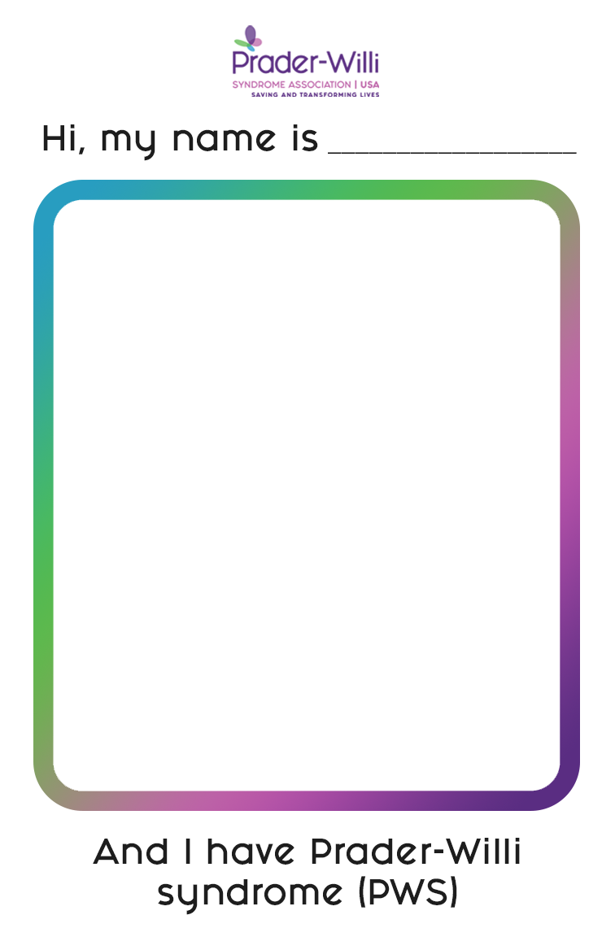

[INSERT NAME HERE]

[INSERT

IMAGE

HERE]

