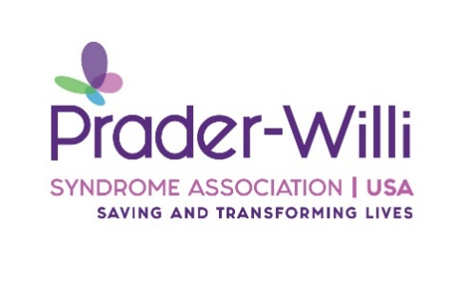
Prader-Willi Syndrome Association | USA Grant Application Process
Celebrating over 40 years as a charitable nonprofit, Prader-Willi Syndrome Association | USA is pleased to offer grant assistance for scientific researchers interested in improving the lives of those with Prader-Willi syndrome. PWSA | USA seeks to fund projects for a 1-2 year period and up to 8% for indirect costs (IDC).
The current focus of PWSA | USA research is supporting projects that have the potential for immediate and high impact for the PWS community. Therefore, PWSA | USA will support research-based translational grants or those showing high promise for translating basic biomedical knowledge to clinical application. The goal is to fast-track better treatment for the syndrome.
At PWSA | USA, we work to integrate what we have learned about the needs of our families through our support programs, then apply that knowledge to identify research that we feel will make an essential and practical difference in the lives of those affected PWS.
Our focus will be on applied research projects focused on Behavioral Issues and Treatment in individuals with PWS. Pharmaceutical and therapeutic approaches will be considered.
Grant Award Process
- Submission of a letter of Intent (LOI): to the PWSA | USA Research Committee for review. The letter should be < 250 words. The letter should give an overview of your organization, a brief outline of your project, and how your project fits with PWSA | USA’s research focus and other potential funding sources.
- Grant Application Due: Thirty days after notification of LOI acceptance.
- Grant Award: Over a 1-2 year period; (the grant proportion for the second year is contingent on the timely receipt of the first year’s progress report and status at the end of the first year).
- Funding of Grant: If accepted, you will receive the funds after all IRB documents are obtained and completed, and all other requirements have been met.
Proposal Submission
Applications must be submitted as a single electronic pdf package to Lynn Garrick at lgarrick@pwsausa.org. Please send a separate email to confirm that the file has been sent, and a confirmation email will be sent when received.
The required font is Times New Roman 12 point. Grant applications should include the following items:
1) Face Page, the face page should include the following information
a. Title of the Project b. Principal Investigator c. Principal Investigator’s Contact Information d. Institutional Contact Information: Name; Mailing Address; Phone Number; Address e. Signatures: The principal investigator should sign the face page.
2) Abstract
3) Budget
4) Justification
5) Period of Support
6) NIH style bio-sketch or CV (2-4 pages) for primary investigators of the Project 7)Research Plan - 5-page limit
8) IRB approval documentation
Grant will be judged on:
- The ability of the Principal Investigator and the research institution to complete the project successfully.
- The potential for the project to provide valuable and accurate insight into an important topic area that would fulfill PWSA | USA goals outlined above.
- The potential of the project to impact rapidly and translate to the PWS community.
- The reasonableness of the time and budget required given the scope of the research and its potential significance.
- The likelihood that the project could not and would not receive funding from alternative sources (NIH, pharmaceuticals, foundations) without pilot data and the possibility of additional funding if the study's objectives are successfully met.

