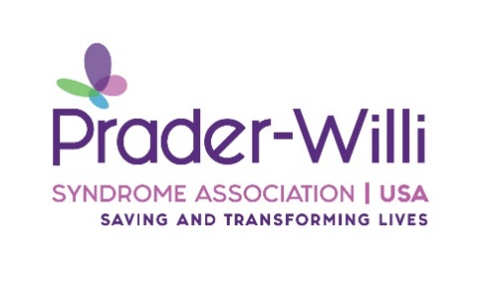
Call for Letters of Intent (LOI)
Prader-Willi Syndrome Association | USA (PWSA | USA) is pleased to offer grant funding for scientific researchers interested in improving the lives of those with Prader-Willi Syndrome (PWS). PWSA | USA is seeking to fund projects for a 1–2-year grant period. Shared grant funding will be allowed at the discretion of the PWSA | USA’s Board of Directors.
The current focus of PWSA | USA research is to support projects that have the potential for immediate and high impact for the PWS community, thus will support research-based translational grants or those showing high promise for translating basic biomedical knowledge to clinical application. The goal is to fast-track better treatment for the syndrome.
At PWSA | USA, we work to integrate what we have learned about the needs of our families through our support programs with research that will make an essential and practical difference in the lives of those with PWS; thus, the following areas of study will be considered for grant review:
Submission of a letter of Intent (LOI) to the PWSA | USA Research Committee for review. The letter should be < 250 words and give an overview of your organization, a brief outline of your project, and how your project fits with PWSA | USA’s research focus and other potential funding sources.
Please send an electronic LOI to Lynn Garrick at lgarrick@pwsausa.org. Please send a separate email to confirm that the file has been sent, and a confirmation email will be sent when received.

